Quote Name: Landscaping Maintenance
Description: See attached
Township Contact: Deb Thompson
Contact Phone Number: (609) 361-6676 Fax: (609) 494-6454
Quote Number: 26-27
Posted Date: January 22, 2026
Dates Quotes are Due by: February 4, 2026 at 10am

Township of Long Beach: Public Works Department
6805 Long Beach Blvd.
Brant Beach, NJ 08008

Annual Service Specifications Outline 2026

Municipal Complex & Dog Park
6805 Long Beach Blvd.
Brant Beach, NJ 08008

Irrigation system start-up (2 Systems)
Completion of (1)4 zone & (1) 13 zone irrigation turn-on procedure. Process includes pressurizing the system, checking and adjusting of all heads and setting the correct watering schedule. Once the system is on, make sure that it is fully functioning. Repair any components of system that are malfunctioning including leaks, broken heads, and nozzle replacements.

Spring Maintenance Service to Landscape Gardens
Spring Maintenance service includes the structural pruning of plant material; the weeding and cleaning of garden beds; supply and install 75lbs of seasonal fertilizer; supply and install 11 yards double ground root mulch; removal of all debris generated from the service and previously existing; the raking, blowing down and cleaning of remaining property. Service to be scheduled between April 1 – May 15

Installation of Summer Annual Flowers at the Municipal Building
Supplying, planting, fertilizing, and mulching of summer flowering annuals. Allow for (20) 8”-10” potted annuals in garden and (60) 8”-10” potted portulaca or similar approved by Long Beach in wall planter. Service to be completed prior to Memorial Day Weekend.

Seasonal Summer Service to Landscaped Gardens
Maintenance Service- 5 Monthly Visits June through October: This service includes, the dead heading of flowering plants, the weeding and cleaning of garden beds; the raking, blowing down, debris removal and cleaning of the remaining area. 2 -4 cubic yards of organic debris removal.

Installation of Fall Flowers in Wall Planter at the Municipal Building

Supply, planting, fertilizing, mulching fall flowering plant material in wall planter. Provide and install (50) 8” – 10” potted mums.

Fall Maintenance Service to Landscaped Gardens

Fall Maintenance service includes the structural pruning of evergreen and deciduous trees and shrubs; the cutting back of ornamental grasses and perennials; application of 75 lbs of fall fertilizer; the removal of annuals; removal of all debris generated from the service and existing; the weeding and cleaning of garden beds; the raking, blowing down and cleaning of remaining area. Service Schedule: November 15 – December 15
Irrigation System Winterization (2 Systems)

Completion of (1)4 zone & (1) 13 zone irrigation shutdown procedure. Process includes the winterization of each zone of the irrigation systems with compressed air. All sprinkler piping is labeled and tagged to identify the shut-off ball valve.
Seasonal Décor

- Supply and install seasonal greens, decor and red bows to wall and planter at the Municipal Building.
- Supply & Deliver (10) 10” Red and White Poinsettias with Bows and Foil for inside Municipal Building
- 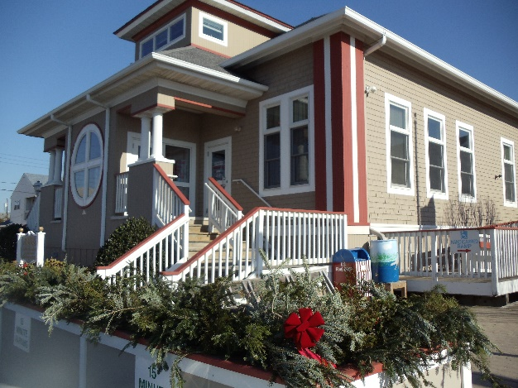

Seasonal Plant Care to all existing established plantings
Spring Dormant Oil: Apply Dormant Oil to suffocate over wintering egg masses.
- Multi-step IPM Program (June, July, August): Diagnose and treat all insect and disease infestations. (Excludes large fungicide and soil drench applications)
- Fall Dormant Oil: Apply Dormant Oil to suffocate newly laid egg masses.

Seasonal Lawn Care to all existing areas in complex
- Application of Balanced Fertilizer to start proper lawn emergence.
- Pre-emergent and post-emergent weed control with micro-nutrients.
- Application of balanced fertilizers throughout season to prevent summer burning and boost plant health after summer stresses.
- Application of slow-release fertilizer applied at 1.5 rate to insure an early spring green up.
- Pet safe fertilizer for dog park.

TOTAL COST FOR TOWNSHIP COMPLEX

VETERAN’S PARK
132nd ST& Long Beach Blvd.
Beach Haven Terrace, NJ 08008

Irrigation system start-up

Completion of 2 zone irrigation turn-on procedure. Process includes pressurizing the system, checking, and adjusting of all heads and setting the correct watering schedule. Once the system is on, make sure that it is fully functioning. Repair any components of system that are malfunctioning including leaks, broken heads, and nozzle replacements.

Spring Maintenance Service to Landscape Gardens
Spring Maintenance service includes: the structural pruning of plant material; the weeding and cleaning of garden beds; the application of seasonal fertilizer (50lbs); the installation of double ground root mulch (10 yards); removal of all debris generated from the service and existing; the raking, blowing down and cleaning of remaining property. Service to be scheduled between April 1 – May 15

Supply & Installation of Summer Annual Flowers
Supplying, planting, fertilizing, and mulching of summer flowering annuals. Allow for (40 - 50) 8”-10” potted annuals in garden. Service to be completed prior to Memorial Day Weekend.

Seasonal Summer Service to Landscaped Gardens
Maintenance Service- 5 Monthly Visits June through October: This service includes, the dead heading of flowering plants, the weeding and cleaning of garden beds; the raking, blowing down, debris removal and cleaning of the remaining property. 2 -4 cubic yards of organic debris removal.

Supply & Installation of Fall Flowers
Supply and install fall flowering plant material and decor including mums and cabbage. Allow for (40 – 50) 8”-10” potted plants. Schedule to be dependent on the condition of summer flowering material but installed no later than November 9, 2026.
Fall Maintenance Service to Landscaped Gardens

Fall Maintenance service includes the structural pruning of evergreen and deciduous trees and shrubs; the cutting back of ornamental grasses and perennials; application of 50 lbs of fall fertilizer; the removal of summer flowering annuals; removal of all debris generated from the service and existing; the weeding and cleaning of garden beds; the raking, blowing down and cleaning of remaining area.
Service Schedule: Must be completed by November 9, 2026, which is prior to Veteran’s Day (observed November 11, 2026)
Memorial Wreath - Veteran’s Day
46” wreath – Supply & deliver to 7910 Long Beach Blvd., Beach Haven Crest, November 10, 2026 (day before Veteran’s Day).
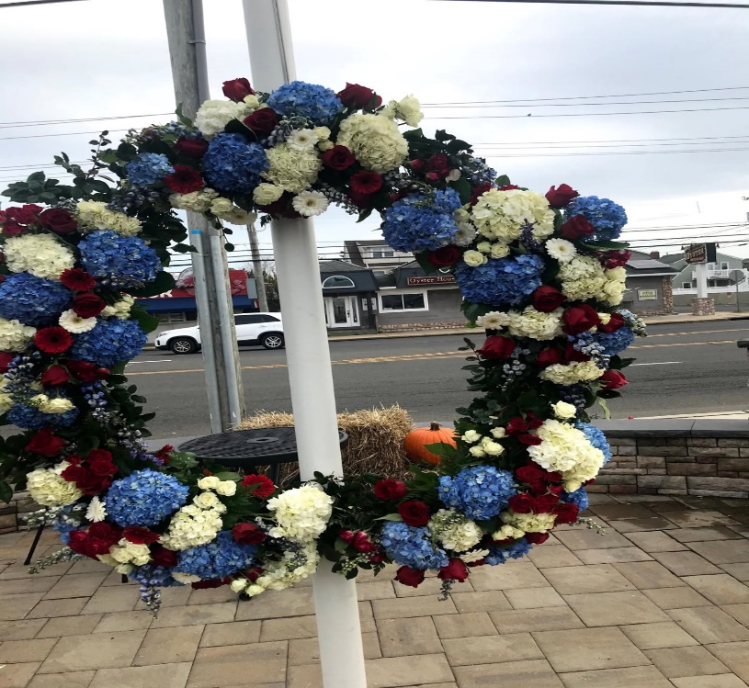

Irrigation System Winterization
Completion of 2 zone irrigation shutdown procedure. Process includes the winterization of each zone of the irrigation systems with compressed air. All sprinkler piping is labeled and tagged to identify the shut-off ball valve.

Seasonal Plant Care to all existing established plantings Spring Dormant Oil: Apply Dormant Oil to suffocate over wintering egg masses.
- Multi-step IPM Program (June, July, August): Diagnose and treat all insect and disease infestations. (Excludes large fungicide and soil drench applications)
- Fall Dormant Oil: Apply Dormant Oil to suffocate newly laid egg masses.

TOTAL COST FOR VETERAN’S PARK

Total Overall Cost:

Term of contract shall be for one (1) year.

*** Please include with your quote: Certificate of Insurance, BRC, W-9 and Hold Harmless***

Company Name Agent Name Contact Telephone #

Email Address: ___________________________________________________________________________

Date Quote Submitted:
Date of Quote Expiration: 12/31/2026

INDEMNIFICATION AGREEMENT

THIS AGREEMENT (“Agreement”), by and between Township of Long Beach (“Township”), whose address is 6805 Long Beach Boulevard, Brant Beach, New Jersey 08008, and _________________________________________________ (“Bidder”), whose address is ___________________________________________________, shall be binding and legally effective upon the execution of the Bidder.

WITNESSETH:

- Bidder expressly, knowingly, and, to the fullest extent permitted by law, agrees to and shall release, indemnify, defend, and hold harmless Township, its elected and appointed officials, officers, employees, agents, volunteers, and others working on behalf of the Township, from and against any loss, damages, claims, causes of action, liabilities, obligations, penalties, demands, municipal mechanic’s liens filed pursuant to N.J.S.A. 2A:44-125, et seq., and any and all other costs and expenses, including attorneys’ fees and costs, threatened against, suffered, and/or incurred by Township, its elected and appointed officials, officers, employees, agents, volunteers, and others working on behalf of the Township arising out of and/or in any manner relating to the contracted and/or licensed activity engaged in and/or the work or services provided by Bidder, its officers, owners, agents, employees, independent contractors, guests, volunteers, others working on behalf of Bidder, and the acts, omissions, and/or negligence of the Bidder, its officers, owners, agents, employees, independent contractors, guests, volunteers, and others working on behalf of or which the Bidder is responsible for arising out of and/or relating to the Bidder’s contract with the Township. Bidder shall be responsible and liable for the payment of any and all of the foregoing attorney’s fees and costs to attorneys of Township’s selection for any investigation and review, pre-litigation, litigation, post-judgment litigation, bankruptcy proceedings, and any and all appeals arising out of and/or relating to this Agreement.

- The terms of this indemnification agreement shall be in addition and cumulative to the indemnification provisions set forth in the general conditions of the contract documents.

3. The existence of any available and/or applicable insurance shall not waive or release Bidder from the Bidder’s obligations set forth in this Agreement.

Dated: ____________ ____________________________________
BIDDER

STATE OF ________________ )
) SS
COUNTY OF _____________ )

On _______, 20__ before me, _________________________, Notary Public in and for said county, personally appeared (signer) who has satisfactorily identified him/her as the signer on behalf of the Bidder to the above-referenced document.

____________________________________
Notary’s Name
Seal


DISCLOSURE OF INVESTMENT ACTIVITIES IN IRAN FORM
STATE OF NEW JERSEY
DEPARTMENT OF THE TREASURY - DIVISION OF PURCHASE AND PROPERTY 33 WEST STATE STREET, P.O. BOX 230 TRENTON, NEW JERSEY 08625-0230

BID SOLICITATION # AND TITLE: ________________________________________________________________________________

VENDOR NAME: ________________________________________________________________________________________

Pursuant to N.J.S.A. 52:32-57, et seq. (P.L. 2012, c.25 and P.L. 2021, c.4) any person or entity that submits a bid or proposal or otherwise proposes to enter into or renew a contract must certify that neither the person nor entity, nor any of its parents, subsidiaries, or affiliates, is identified on the New Jersey Department of the Treasury’s Chapter
25 List as a person or entity engaged in investment activities in Iran. The Chapter 25 list is found on the Division’s website at https://www.state.nj.us/treasury/purchase/pdf/Chapter25List.pdf. Vendors/Bidders must review this list prior to completing the below certification. If the Director of the Division of Purchase and Property finds a person or entity to be in violation of the law, s/he shall take action as may be appropriate and provided by law, rule or contract, including but not limited to, imposing sanctions, seeking compliance, recovering damages, declaring the party in default and seeking debarment or suspension of the party.

CHECK THE APPROPRIATE BOX


I certify, pursuant to N.J.S.A. 52:32-57, et seq. (P.L. 2012, c.25 and P.L. 2021, c.4), that neither the Vendor/Bidder listed above nor any of its parents, subsidiaries, or affiliates is listed on the New Jersey Department of the Treasury’s Chapter 25 List of entities determined to be engaged in prohibited activities in Iran.

OR

I am unable to certify as above because the Vendor/Bidder and/or one or more of its parents, subsidiaries, or affiliates is listed on the New Jersey Department of the Treasury’s Chapter 25 List. I will provide a detailed, accurate and precise description of the activities of the Vendor/Bidder, or one of its parents, subsidiaries or affiliates, has engaged in regarding investment activities in Iran by completing the information requested below.

Entity Engaged in Investment Activities _____________________________________________
Relationship to Vendor/ Bidder _____________________________________________
Description of Activities ____________________________________________

Duration of Engagement ____________________________________________________________________
Anticipated Cessation Date
*Attach Additional Sheets If Necessary
.

CERTIFICATION
I, the undersigned, certify that I am authorized to execute this certification on behalf of the Vendor, that the foregoing information and any attachments hereto, to the best of my knowledge are true and complete. I acknowledge that the State of New Jersey is relying on the information contained herein, and that the Vendor is under a continuing obligation from the date of this certification through the completion of any contract(s) with the State to notify the State in writing of any changes to the information contained herein; that I am aware that it is a criminal offense to make a false statement or misrepresentation in this certification. If I do so, I may be subject to criminal prosecution under the law, and it will constitute a material breach of my contract(s) with the State, permitting the State to declare any contract(s) resulting from this certification void and unenforceable.

Signature Date

Print Name and Title

CERTIFICATION OF NON-INVOLVEMENT IN PROHIBITED ACTIVITIES IN RUSSIA OR BELARUS
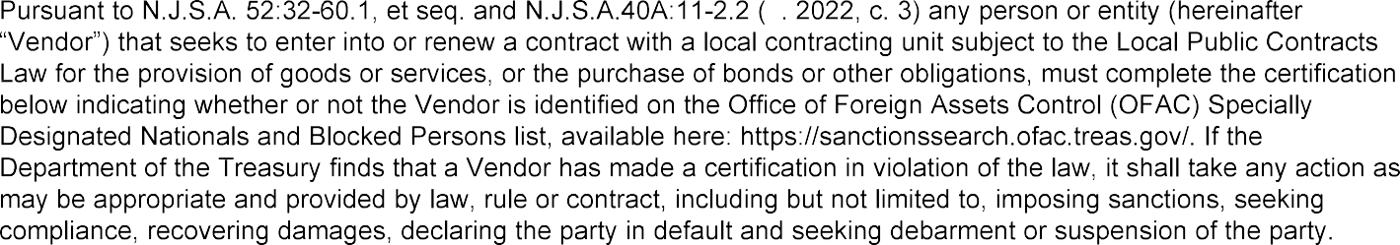

(Check the Appropriate Box)

- That the Vendor is not identified on the OFAC Specially Designated Nationals and Blocked Persons list on account of activity related to Russia and/or Belarus.

OR

- That I am unable to certify as to “A” above, because the Vendor is identified on the OFAC Specially Designated Nationals and Blocked Persons list on account of activity related to Russia and/or Belarus.

OR

That I am unable to certify as to “A” above, because the Vendor is identified on the OFAC Specially Designated Nationals and Blocked Persons list. However, the Vendor is engaged in activity related to Russia
- and/or Belarus consistent with federal law, regulation, license or exemption. A detailed description of how
the Vendor’s activity related to Russia and/or Belarus is consistent with federal law is set forth below.

(Attach Additional Sheets If Necessary.)

Signature of Vendor’s Authorized Representative Date

Print Name and Title of Vendor’s Authorized Representative Vendor’s FEIN

Vendor’s Name Vendor’s Phone Number

Vendor’s Address (Street Address) Vendor’s Fax Number

Vendor’s Address (City/State/Zip Code) Vendor’s Email Address

i Vendor means: (1) A natural person, corporation, company, limited partnership, limited liability partnership, limited liability company, business association, sole proprietorship, joint venture, partnership, society, trust, or any other nongovernmental entity, organization, or group; (2) Any governmental entity or instrumentality of a government, including a multilateral development institution, as defined in Section 1701(c)(3) of the International Financial Institutions Act, 22 U.S.C. 262r(c)(3); or (3) Any parent, successor, subunit, direct or indirect subsidiary, or any entity under common ownership or control with, any entity described in paragraph (1) or (2).

