Mixed Rigid Plastic

Recycling Program
Drop off at Ocean County Northern and Southern Recycling Centers
Mon-Sat 7:30 AM - 3:00 PM /

Accepted
Buckets - Milk crates - Laundry
baskets - Lawn furniture - Landscape & microwave trays - Totes (Any Size) - Toys & playhouses - Pallets - Empty garbage cans (any size) - Bed liners ( from trucks).
Plastic ONLV
Not Accepted
PVC, Vinyl Siding, Styrofoam , Coolers, Flexible Water Hoses, Plastic Shelving, Medical waste, Dish Drains, Flower pots, Small plastic containers Oil/Chemical containers, Plastic drums (any size}, Car seats, Pet carriers, Plastic closet organizers or 5 gallon water bottles.

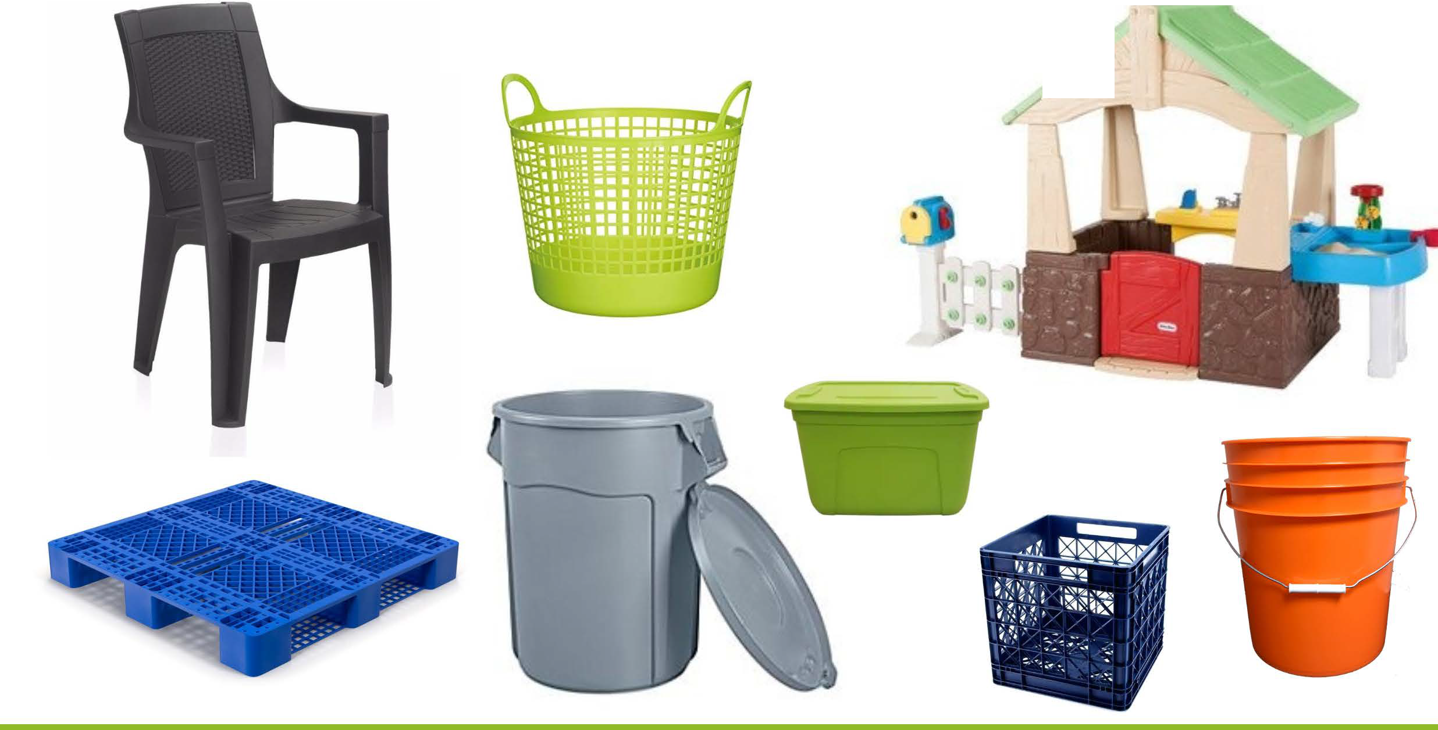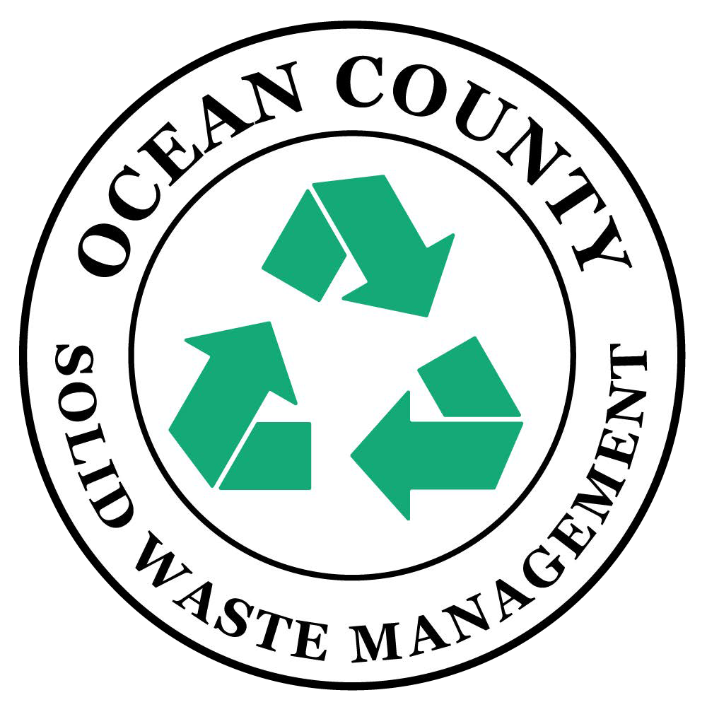
Ocean County Department of Solid Waste Management co.ocean.nj.us/recycle facebook.com/ocswm

